GIGA New User Setup Instructions

1. Active Directory Account

-Administrative Tools – Users and Computers

Right click the Users folder and select New – User

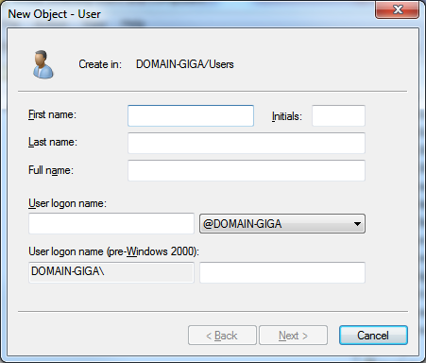

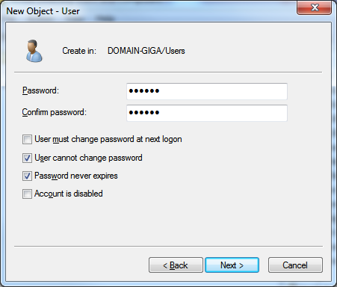

Click next and then right click on the newly created user account and select properties.

The following tabs will need to be populated in AD for the new user.

General – Verify user account info and add user’s email address

Account – Verify user cannot change password and password never expires are checked.

Profile – Add MAPDRV2.bat to the Logon Script: (this will map the S: drive)

Member Of – Make sure to add the user to the DLO-USERS and P21USERS Groups.

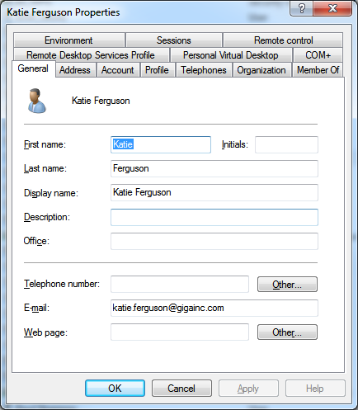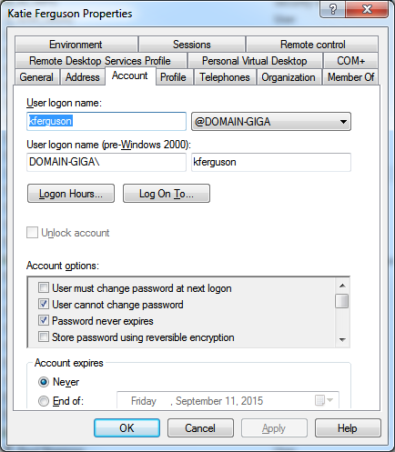

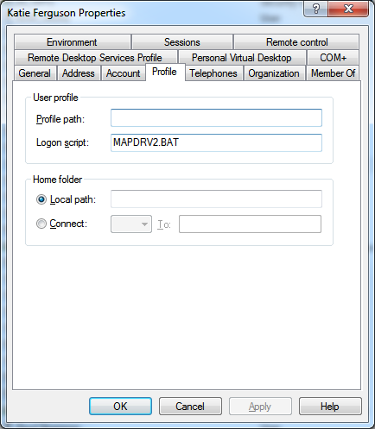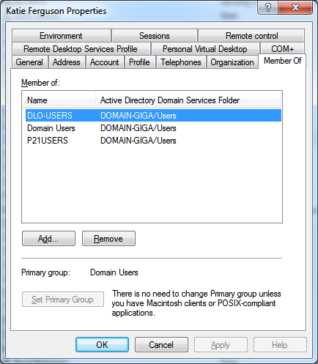

1. Email Account Setup

Login to Cox Mail Control Panel – (must be an mail administrator)

<https://control.coxmail.com/selfcare/Login.do>

Click on User Management and the E-Mailboxes Available link to create a new mail account. Record the account and password information in Coxmail spreadsheet.

1. Prophet 21 Setup
   1. Add to P21 User
2. Phone Setup